**Android Application Development**

**Final Semester Lab Exam**

**H Uday Reddy**

**CH.EN.U4CYS21023**

**Aim:**

1. Create a registration page.
2. Based on dummy Gmail as user name and password – Login.
3. Logout.
4. Then login again and the session should be maintained the Welcome back “Gmail id” should be display.

**Codes:**

**activity_main.xml:**

<?xml version="1.0" encoding="utf-8"?>  
<LinearLayout xmlns:android="http://schemas.android.com/apk/res/android"  
 xmlns:app="http://schemas.android.com/apk/res-auto"  
 xmlns:tools="http://schemas.android.com/tools"  
 android:layout_width="match_parent"  
 android:layout_height="match_parent"  
 android:background="@drawable/new_login_gradients"  
 android:orientation="vertical"  
 android:paddingVertical="20dp"  
 android:paddingHorizontal="20dp"  
 tools:context=".MainActivity">  
  
 <ImageView  
 android:id="@+id/imageView"  
 android:layout_width="50dp"  
 android:layout_height="50dp"  
 android:layout_gravity="right"  
 android:src="@drawable/amrita"  
 />  
  
 <TextView  
 android:layout_width="wrap_content"  
 android:layout_height="wrap_content"  
 android:text="Aditya Peddireddy"  
 android:paddingLeft="250dp"  
 android:textColor="#ffffff"/>  
  
 <TextView  
 android:layout_width="wrap_content"  
 android:layout_height="wrap_content"  
 android:text="CH.EN.UCYS21055"  
 android:paddingLeft="250dp"  
 android:textColor="#ffffff"/>  
   
 <ScrollView  
 android:layout_width="match_parent"  
 android:layout_height="match_parent">  
  
 <LinearLayout  
 android:layout_width="match_parent"  
 android:layout_height="wrap_content"  
 android:layout_gravity="center"  
 android:orientation="vertical">  
   
 <EditText  
 android:layout_width="match_parent"  
 android:layout_height="wrap_content"  
 android:id="@+id/etLogGmail"  
 android:layout_marginTop="50dp"  
 android:background="@android:color/transparent"  
 android:drawablePadding="12dp"  
 android:ems="10"  
 android:inputType="textEmailAddress"  
 android:padding="10dp"  
 android:hint="Email"  
 android:textColorHint="#ffffff"  
 android:maxLines="1" />  
  
 <View  
 android:layout_width="match_parent"  
 android:layout_height="1dp"  
 android:background="#f9d7db" />  
  
 <EditText  
 android:layout_width="match_parent"  
 android:layout_height="wrap_content"  
 android:background="@android:color/transparent"  
 android:drawablePadding="12dp"  
 android:ems="10"  
 android:inputType="textPassword"  
 android:padding="10dp"  
 android:hint="Password"  
 android:textColorHint="#ffffff"  
 android:maxLines="1"  
 android:layout_marginTop="5dp"  
 android:id="@+id/etLoginPassword" />  
   
 <View  
 android:layout_width="match_parent"  
 android:layout_height="1dp"  
 android:background="#f9d7db" />  
   
 <Button  
 android:layout_width="match_parent"  
 android:layout_height="wrap_content"  
 android:id="@+id/btnLogin"  
 android:background="@drawable/background_login"  
 android:text="Login"  
 android:layout_marginTop="30dp"  
 android:textColor="#ffffff"  
 android:textSize="18dp"  
 android:padding="16dp"  
 android:clickable="true"/>  
  
 <TextView  
 android:id="@+id/tvRegister"  
 android:layout_width="200dp"  
 android:layout_height="30dp"  
 android:layout_marginEnd="8dp"  
 android:layout_marginStart="8dp"  
 android:layout_marginTop="18dp"  
 android:layout_gravity="center_horizontal"  
 android:text="New User? Register"  
 android:textSize="22sp" />  
  
 </LinearLayout>  
 </ScrollView>  
  
  
</LinearLayout>

**activity_login_success.xml:**

<?xml version="1.0" encoding="utf-8"?>  
<RelativeLayout  
 xmlns:android="http://schemas.android.com/apk/res/android"  
 xmlns:app="http://schemas.android.com/apk/res-auto"  
 xmlns:tools="http://schemas.android.com/tools"  
 android:layout_width="match_parent"  
 android:layout_height="match_parent"  
 tools:context=".LoginSuccess"  
 android:background="@drawable/new_login_gradients">  
 <TextView  
 android:layout_width="wrap_content"  
 android:layout_height="wrap_content"  
 android:text="Welcome Back!"  
 android:textColor="@android:color/white"  
 android:textSize="28sp"  
 android:layout_centerInParent="true"/>  
  
 <TextView  
 android:layout_width="wrap_content"  
 android:layout_height="wrap_content"  
 android:textSize="28sp"  
 android:textColor="@color/white"  
 android:layout_marginTop="500dp"  
 android:layout_centerHorizontal="true"  
 android:id="@+id/mailid"/>  
  
 <Button  
 android:layout_width="wrap_content"  
 android:layout_height="wrap_content"  
 android:layout_alignParentBottom="true"  
 android:layout_marginLeft="250dp"  
 android:text="Logout"  
 android:textSize="15sp"  
 android:id="@+id/logout" />  
  
</RelativeLayout>

**activity_Register.xml:**

<?xml version="1.0" encoding="utf-8"?>  
<LinearLayout xmlns:android="http://schemas.android.com/apk/res/android"  
 xmlns:app="http://schemas.android.com/apk/res-auto"  
 xmlns:tools="http://schemas.android.com/tools"  
 android:layout_width="match_parent"  
 android:layout_height="match_parent"  
 android:background="@drawable/new_login_gradients"  
 android:orientation="vertical"  
 android:paddingVertical="16dp"  
 android:paddingHorizontal="18dp"  
 tools:context=".RegisterActivity">  
 <ScrollView  
 android:layout_width="match_parent"  
 android:layout_height="match_parent">  
  
 <LinearLayout  
 android:layout_width="match_parent"  
 android:layout_height="match_parent"  
 android:orientation="vertical">  
  
  
 <EditText  
 android:id="@+id/etRegName"  
 android:layout_width="match_parent"  
 android:layout_height="wrap_content"  
 android:layout_marginTop="50dp"  
 android:background="@android:color/transparent"  
 android:drawablePadding="12dp"  
 android:ems="10"  
 android:inputType="textEmailAddress"  
 android:padding="8dp"  
 android:hint="Name"  
 android:textColorHint="#ffffff"  
 android:maxLines="1" />  
 <View  
 android:layout_width="match_parent"  
 android:layout_height="1dp"  
 android:background="#f9d7db" />  
 <EditText  
 android:id="@+id/etRegPhone"  
 android:layout_width="match_parent"  
 android:layout_height="wrap_content"  
 android:layout_marginTop="8dp"  
 android:background="@android:color/transparent"  
 android:drawablePadding="12dp"  
 android:ems="10"  
 android:inputType="number"  
 android:padding="8dp"  
 android:hint="Phone number"  
 android:textColorHint="#ffffff"  
 android:maxLines="1" />  
 <View  
 android:layout_width="match_parent"  
 android:layout_height="1dp"  
 android:background="#f9d7db" />  
 <EditText  
 android:id="@+id/etRegGmail"  
 android:layout_width="match_parent"  
 android:layout_height="wrap_content"  
 android:layout_marginTop="8dp"  
 android:background="@android:color/transparent"  
 android:drawablePadding="12dp"  
 android:ems="10"  
 android:inputType="textEmailAddress"  
 android:padding="8dp"  
 android:hint="Gmail"  
 android:textColorHint="#ffffff"  
 android:maxLines="1" />  
 <View  
 android:layout_width="match_parent"  
 android:layout_height="1dp"  
 android:background="#f9d7db" />  
  
 <EditText  
 android:layout_width="match_parent"  
 android:layout_height="wrap_content"  
 android:inputType="textPassword"  
 android:ems="10"  
 android:id="@+id/etRegPassword"  
 android:drawablePadding="12dp"  
 android:padding="8dp"  
 android:textColorHint="#ffffff"  
 android:hint="Password"  
 android:maxLines="1"  
 android:background="@android:color/transparent"  
 android:layout_marginTop="4dp" />  
 <View  
 android:layout_width="match_parent"  
 android:layout_height="1dp"  
 android:background="#f9d7db" />  
 <Button  
 android:layout_width="match_parent"  
 android:layout_height="wrap_content"  
 android:id="@+id/btnRegLogin"  
 android:background="@drawable/background_login"  
 android:text="Register"  
 android:layout_marginTop="30dp"  
 android:textSize="18sp"  
 android:textColor="#ffffff"  
 android:padding="16dp"  
 android:clickable="true"/>  
 <Button  
 android:layout_width="match_parent"  
 android:layout_height="wrap_content"  
 android:id="@+id/btnGotoLogin"  
 android:background="@drawable/background_login"  
 android:text="Login"  
 android:layout_marginTop="30dp"  
 android:textSize="18sp"  
 android:textColor="#ffffff"  
 android:padding="16dp"  
 android:clickable="true"/>  
  
 </LinearLayout>  
 </ScrollView>  
  
  
  
</LinearLayout>

**Under drawable section:**

**backgound_login.xml**

<?xml version="1.0" encoding="utf-8"?>  
<shape  
 xmlns:android="http://schemas.android.com/apk/res/android">  
 <stroke  
 android:width="2dp"  
 android:color="#ffffff"/>  
 <corners  
 android:radius="25dp" />  
  
 <padding  
 android:left="2dp"  
 android:right="2dp"  
 android:top="2dp"  
 android:bottom="2dp"/>  
  
 <solid android:color="#ffffff"/>  
  
</shape>

**new_login_gradients.xml:**

<?xml version="1.0" encoding="utf-8"?>  
<shape xmlns:android="http://schemas.android.com/apk/res/android"  
 android:shape="rectangle">  
 <gradient  
 android:angle="90"  
 android:endColor="#00BCD4"  
 android:centerColor="#2196F3"  
 android:startColor="#3F51B5" />  
 <padding  
 android:bottom="7dp"  
 android:left="7dp"  
 android:right="7dp"  
 android:top="7dp" />  
</shape>

**MainActivity.java:**

package com.example.finallab;  
  
import android.content.Intent;  
import android.database.Cursor;  
import android.database.sqlite.SQLiteDatabase;  
import android.database.sqlite.SQLiteOpenHelper;  
import androidx.appcompat.app.AppCompatActivity;  
import android.os.Bundle;  
import android.view.View;  
import android.widget.Button;  
import android.widget.EditText;  
import android.widget.TextView;  
import android.widget.Toast;  
  
public class MainActivity extends AppCompatActivity {  
 private TextView tvRegister;  
 private EditText etLoginGmail,etLoginPassword;  
 private Button loginButton;  
  
 private SQLiteDatabase db;  
 private SQLiteOpenHelper openHelper;  
 private Cursor cursor;  
  
  
 @Override  
 protected void onCreate(Bundle savedInstanceState) {  
 super.onCreate(savedInstanceState);  
 setContentView(R.layout.*activity_main*);  
  
 openHelper = new DatabaseHelper(this);  
 db = openHelper.getReadableDatabase();  
 tvRegister = findViewById(R.id.*tvRegister*);  
 etLoginGmail = findViewById(R.id.*etLogGmail*);  
 etLoginPassword = findViewById(R.id.*etLoginPassword*);  
 loginButton = findViewById(R.id.*btnLogin*);  
  
 loginButton.setOnClickListener(new View.OnClickListener() {  
 @Override  
 public void onClick(View v) {  
 String email = etLoginGmail.getText().toString().trim();  
 String password = etLoginPassword.getText().toString().trim();  
 if (email.isEmpty() || password.isEmpty()) {  
 Toast.*makeText*(MainActivity.this, "Enter your Email and Password to login", Toast.*LENGTH_SHORT*).show();  
 } else {  
 cursor = db.rawQuery("SELECT *FROM " + DatabaseHelper.*TABLE_NAME* + " WHERE " + DatabaseHelper.*COL_4* + "=? AND " + DatabaseHelper.*COL_5* + "=?", new String[]{email, password});  
 if (cursor != null) {  
 if (cursor.getCount() > 0) {  
 Intent intent = new Intent(MainActivity.this, LoginSuccess.class);  
 intent.putExtra("email", email);  
 startActivity(intent);  
 Toast.*makeText*(getApplicationContext(), "Login sucess", Toast.*LENGTH_SHORT*).show();  
  
 } else {  
 Toast.*makeText*(getApplicationContext(), "Login error", Toast.*LENGTH_SHORT*).show();  
 }  
 }  
 }  
 }  
 });  
  
  
  
 tvRegister.setOnClickListener(new View.OnClickListener() {  
 @Override  
 public void onClick(View v) {  
 startActivity(new Intent(MainActivity.this,RegisterActivity.class));  
 finish();  
 }  
 });  
  
 }  
}

**RegisterActivity.java:**

package com.example.finallab;  
import android.content.ContentValues;  
import android.content.Intent;  
import android.database.sqlite.SQLiteDatabase;  
import android.database.sqlite.SQLiteOpenHelper;  
import androidx.appcompat.app.AppCompatActivity;  
import android.os.Bundle;  
import android.view.View;  
import android.widget.Button;  
import android.widget.EditText;  
import android.widget.Toast;  
  
public class RegisterActivity extends AppCompatActivity {  
 private Button registerBtn,gotoLoginBtn;  
  
 private SQLiteOpenHelper openHelper;  
 private SQLiteDatabase db;  
 private EditText regName,regPhone,regGmail,regPassword;  
 @Override  
 protected void onCreate(Bundle savedInstanceState) {  
 super.onCreate(savedInstanceState);  
 setContentView(R.layout.*activity_register*);  
  
 openHelper = new DatabaseHelper(this);  
  
 registerBtn = findViewById(R.id.*btnRegLogin*);  
 gotoLoginBtn = findViewById(R.id.*btnGotoLogin*);  
 regName = findViewById(R.id.*etRegName*);  
 regPhone = findViewById(R.id.*etRegPhone*);  
 regGmail = findViewById(R.id.*etRegGmail*);  
 regPassword = findViewById(R.id.*etRegPassword*);  
  
 registerBtn.setOnClickListener(new View.OnClickListener() {  
 @Override  
 public void onClick(View v) {  
 db = openHelper.getWritableDatabase();  
 String fname = regName.getText().toString().trim();  
 String fPhone = regPhone.getText().toString().trim();  
 String fGmail = regGmail.getText().toString().trim();  
 String fPassword = regPassword.getText().toString().trim();  
 if (fname.isEmpty() || fPassword.isEmpty() || fGmail.isEmpty() || fPhone.isEmpty()) {  
 Toast.*makeText*(RegisterActivity.this, "Please fill all the details", Toast.*LENGTH_SHORT*).show();  
 } else {  
 insertData(fname,fPhone,fGmail,fPassword);  
 Toast.*makeText*(RegisterActivity.this, "Registration Successful", Toast.*LENGTH_SHORT*).show();  
 }  
 }  
 });  
  
 gotoLoginBtn.setOnClickListener(new View.OnClickListener() {  
 @Override  
 public void onClick(View v) {  
 startActivity(new Intent(RegisterActivity.this,MainActivity.class));  
 finish();  
 }  
 });  
 }  
 public void insertData(String fname,String fPhone,String fGmail,String fPassword){  
 ContentValues contentValues = new ContentValues();  
 contentValues.put(DatabaseHelper.*COL_2*,fname);  
 contentValues.put(DatabaseHelper.*COL_3*,fPhone);  
 contentValues.put(DatabaseHelper.*COL_4*,fGmail);  
 contentValues.put(DatabaseHelper.*COL_5*,fPassword);  
  
 long id = db.insert(DatabaseHelper.*TABLE_NAME*,null,contentValues);  
 }  
}

**LoginSuccess.java:**

package com.example.finallab;  
  
import androidx.appcompat.app.AppCompatActivity;  
  
import android.content.Intent;  
import android.os.Bundle;  
import android.widget.Button;  
import android.widget.TextView;  
  
public class LoginSuccess extends AppCompatActivity {  
  
 private TextView textViewDisplayInput;  
 private Button logout;  
  
 @Override  
 protected void onCreate(Bundle savedInstanceState) {  
 super.onCreate(savedInstanceState);  
 setContentView(R.layout.*activity_login_success*);  
  
 textViewDisplayInput = findViewById(R.id.*mailid*);  
  
 Intent intent = getIntent();  
 String email = intent.getStringExtra("email");  
  
 textViewDisplayInput.setText(email);  
  
 logout = findViewById(R.id.*logout*);  
 logout.setOnClickListener(v -> {  
 Intent intent1 = new Intent(LoginSuccess.this, MainActivity.class);  
 startActivity(intent1);  
 });  
 }  
}

**DatabaseHelper.java:**

package com.example.finallab;  
  
import android.content.Context;  
import android.database.sqlite.SQLiteDatabase;  
import android.database.sqlite.SQLiteOpenHelper;  
  
public class DatabaseHelper extends SQLiteOpenHelper {  
 public static final String *DATABASE_NAME*="register.db";  
 public static final String *TABLE_NAME*="registration";  
 public static final String *COL_1*="ID";  
 public static final String *COL_2*="Name";  
 public static final String *COL_3*="Phone";  
 public static final String *COL_4*="Gmail";  
 public static final String *COL_5*="Password";  
 public DatabaseHelper(Context context) {  
 super(context, *DATABASE_NAME*, null, 1);  
 }  
  
 @Override  
 public void onCreate(SQLiteDatabase db) {  
 db.execSQL("CREATE TABLE " + *TABLE_NAME* + " (ID INTEGER PRIMARY KEY AUTOINCREMENT,Name TEXT,Phone TEXT,Gmail TEXT,Password TEXT)");  
 }  
 @Override  
 public void onUpgrade(SQLiteDatabase db, int oldVersion, int newVersion) {  
 db.execSQL("DROP TABLE IF EXISTS " +*TABLE_NAME*);  
 onCreate(db);  
 }  
}

**Output:**

**Virtual Device:**

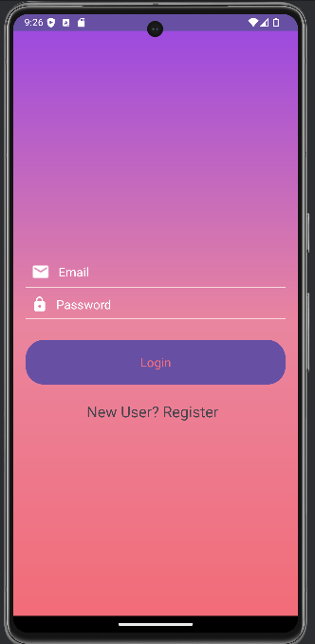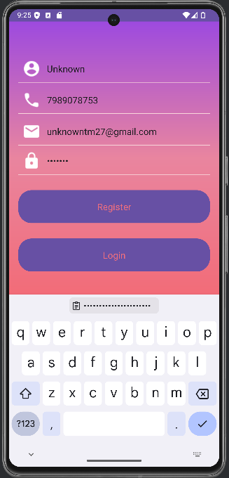

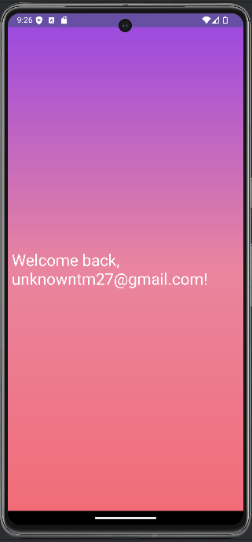

**Remote Device:**

